THE RIVERSIDE PRACTICE
Decontamination of
Equipment Policy

Contents Page
Contents Page
1. Introduction.............................................................................................. 4
2. Definitions................................................................................................ 4
3. Evidence of decontamination................................................................... 4
4. Methods of decontamination.................................................................... 5
5. Cleaning .................................................................................................. 5
6. Disinfection.............................................................................................. 5
7. Sterilisation.............................................................................................. 6
8. Decontamination of equipment prior to inspection, service or repair ..... 6
9. Symbols and their meanings.................................................................... 7
10. Infection risks and categories .................................................................7
11. Infection Prevention and Control resources, education and training...... 8
12. References ............................................................................................. 8
13. Appendices.............................................................................................. 9

Appendix 1: Declaration of Contamination Status.........................................10

DECONTAMINATION OF
EQUIPMENT
1. Introduction
1. Introduction
In order to ensure safe systems of work and to prevent transmission of
infection, it is essential that decontamination of equipment after use on a
patient is undertaken to prevent the transmission of infection. This is in
accordance with the requirements of the Health and Social Care Act 2008:
Code of Practice on the prevention and control of infections and related
guidance.
2. Defin
2. Definitions
ns
• Contamination: The soiling of an object with harmful, potentially
infectious or unwanted matter.
• Decontamination: A combination of processes that removes or
destroys contamination.
• Cleaning: A process that will physically remove contamination
(blood, vomit, faeces, etc.) and many microorganisms
using detergent and water.
• Disinfection: A process to reduce the number of micro-organisms
to a less harmful level. The ability to kill spores is
dependent on the type of disinfectant used.
• Sterilisation: A process that removes or destroys all organisms
including spores.
3. Evidence of decontamination
3. Evidence of decontamination
It is recommended that monthly audits to assess the standard of cleanliness of
equipment be carried out. An audit tool is available to download at
www.infectionpreventioncontrol.co.uk
.
Re-usable medical equipment that has been cleaned or disinfected should be
labelled, e.g. with ‘I am clean’ indicator tape or label/documentation giving
details of the date of cleaning and signed by the person who performed the
decontamination.
It is also recommended that equipment not in regular use should be checked
on a monthly basis and decontaminated as appropriate and re-labelled.

4. Methods of decontamination
of decontamination
There are 3 levels of decontamination, cleaning, disinfection and sterilisation.
All equipment should be adequately decontaminated after use on a patient.
The method recommended will depend on the manufacturer’s instructions, a
risk assessment of the procedure and the item being used in accordance with
Control of Substances Hazardous to Health (COSHH) Regulations (see Section
12 Infection risks and categories).
5

5. Cleaning Cle
aning
• Detergent wipes or detergent and warm water and single use cloths are
recommended.
• Cleaning is essential before disinfection or sterilisation is carried out.
• All equipment that has been cleaned must be dried thoroughly before
storage.
6
6. Disinfection
• Disinfectants can be in the form of a wipe, e.g. Clinell Universal, Steri-7
extra or as chlorine releasing tablets, liquids or granules, such as Haztabs,
Presept, Chlor-Clean, Tristel Fuse.
• A disinfectant will not be effective if there is dirt or visible soiling present,
e.g. urine, blood. Therefore, if the disinfectant does not contain a detergent
the equipment should be cleaned before a disinfectant is used.
• Some disinfectant products contain both a detergent and a disinfectant, e.g.
Clinell Universal wipes, Chlor-Clean releasing tablets. This means
equipment does not need to be cleaned before disinfection.
• When disinfecting equipment always follow the manufacturer’s instructions,
some equipment will have specific instructions which should be followed,
e.g. Propulse machine, peak flow.
• A disinfectant should be used for any equipment contaminated with
splashes of blood. The appropriate disinfectant should have virucidal
properties effective against hepatitis B, hepatitis C and HIV.
• A disinfectant should be used for equipment that has been in contact with a
patient with a known or suspected infection, non-intact skin, mucous
membranes or body fluids.
• To ensure a disinfectant solution works effectively, it is important that the
correct amount of disinfectant and water are used. If a weaker solution is

used, the micro-organisms will not be killed, too strong, and equipment or
surfaces can be damaged.
• If a chlorine-based solution is used it should be at a dilution of 1,000 ppm.
• As diluted chlorine-based disinfectant solutions are unstable and become
less effective after 24 hours, a new solution should be made each day.
• When using disinfectant products, always wear disposable gloves and an
apron and if indicated, eye protection.
• COSHH regulations must be adhered to at all times.
7. Sterilisation
7. Sterilisation
The use of bench top steam sterilisers (autoclaves) is not recommended.
Sterilisation is a specialist means of decontamination of equipment. Reusable
items requiring sterilisation after use must be sent to an accredited
Decontamination Services Facility. Alternatively, single use disposable
equipment should be used.
8. Decontamination of equipment prior to
8. Decontamination of equipment prior to
8. Decontamination of equipment prior to
inspection, service or repair
service or repair
When equipment requires servicing or repair, documentation should
accompany the equipment stating if the item has or has not been
decontaminated (see Appendix 1).
Flow chart for handling of equipment prior to inspection, service, repair,
return to lending organisation or investigation of adverse incident.
Note: It is illegal to send contaminated items through the post.
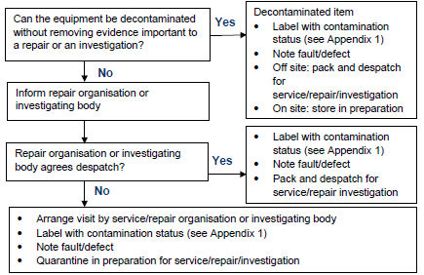
9. Symbols and their meanings
9. Symbols and their meanings
Single use
Items for single use, e.g. disposable forceps, auroscope ear piece, must not be
used again as they are designed to be used only once. Items intended for
single use are packaged with this symbol or are labelled ‘single use’.
Single patient use
Items for single patient use, e.g. nebuliser, mask, spacers, can be
decontaminated after each use and re-used on the same patient, but cannot be
used on another patient. It will be indicated on the packaging ‘single patient
use’. If spacers are required for reversibility testing, disposable single use
spacers can be used.
GP Practices who disregard this information and prepare single-use devices for
further use, may be transferring legal liability for the safe performance of the
product from the manufacturer to themselves, or the organisation that employs
them.
For any queries regarding reprocessing of equipment, advice should be
sought from the manufacturer or your local Community Infection
Prevention and Control or Public Health England Team.
10. Infection risks and categories
Risk category Level of
10. Infection risks and categories
Method Examples
OF EQUIPMENT
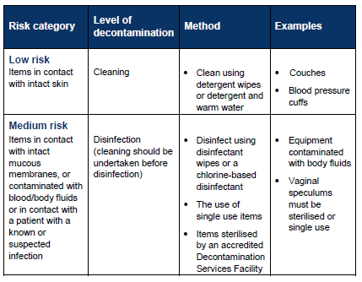

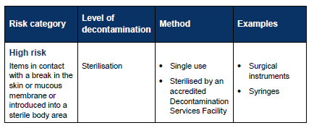Prevention and Control resources,
11. Infection Prevention and Control resources,
education and training
education and training
The Community Infection Prevention and Control (IPC) Team have produced
a wide range of innovative educational and IPC resources designed to assist
your Practice in achieving compliance with the Health and Social Care Act
2008 and CQC registration requirements.
These resources are either free to download from the website or available at a
minimal cost covering administration and printing:
• Over 20 IPC Guidance documents (Policies) for General Practice
• ‘Preventing Infection Workbook for General Practice’
• ‘IPC CQC Inspection Preparation Pack for General Practice’
• IPC audit tools, posters, leaflets and factsheets
• ‘IPC Advice Bulletin for GP Practice Staff’
In addition, we hold educational study events in North Yorkshire and can
arrange bespoke training packages and ‘Mock IPC CQC Inspections’. Prices
vary depending on your requirements and location.
Further information on these high quality evidence-based resources is
available at www.infectionpreventioncontrol.co.uk.
12. References
12. References
Department of Health (2015) The Health and Social Act 2008. Code of
Practice for the Prevention and control of healthcare associated infections
Department of Health (2006) Essential steps to safe, clean care
Doughty L Lister S (Eds) (2008) The Royal Marsden Hospital Manual of
Clinical Nursing Procedures 7th Edition
N O
Loveday et al (2014) epic3: National Evidence-Based Guidelines for Preventing
Healthcare-Associated Infections in NHS Hospital in England
13. Appendices
13. Appendices
Appendix 1: Declaration of Contamination Status

